1

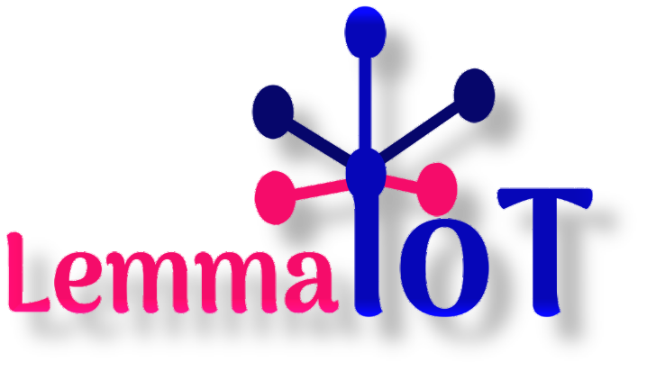

​

**Cloud Solution |** Getting you Going Soft

**Digital Business Card Guild**

Whether it's a personal profile webpage, business profile webpage or it’s just for a product or special for a project work even or if its a landing page to capture emails, or something a bit more

elaborate, this package is just for you.

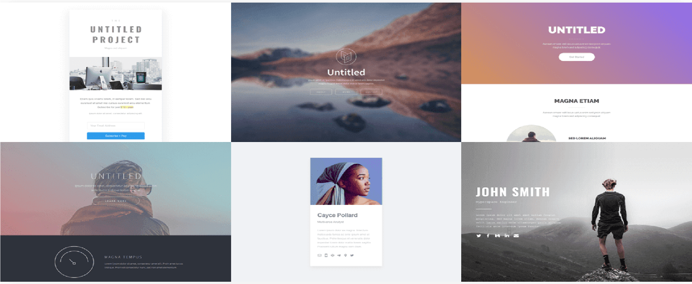 **Feature of this Platform**

**Basic features** include design of a responsive webpage with high quality image, holds videos, unlimited elements, linking features to external pages or websites and our free maintenance service. (Available for Basic, Lite & Pro)

**Blocks & Buttons** includes icons button and shaped customised button to leads/linked to your contacts, social media profile page and other pages you might want to direct users to, linked to another website pages or even more, like click to download, click to watch, click to play or anything of such. (Available for Basic, Lite & Pro)​

**Custom Design** such as creating for you a different and unique design other than the available templates on our website, or to use your recommended design of any kind or ask us to design a unique style just for you and you alone. (Available for Basic, Lite & Pro​)​

**Responsive Forms/Advance Form** which include a contact form, registration form booking form, application form or any kind of custom form you can think of, all this and more is available for you. (Available on Lite & Pro)

**Custom Domain** Name includes publishing your website with your custom domains name you own with full SSL support (via Let's Encrypt).

(Available on Pro)

***NOTE: If you want .com (i.e. www.yourname.com), you have to pay extra ₦12,500 which might be more or less depending on exchange rate***

**Automate Response** which includes sending of messages/response automatically on your behalf to your visitors whenever they fill out your form, also to automatically post contents to your facebook and twitter page as well as automatic document generation. Visit our Website to [Learn](https://www.lemmaiot.com.ng/automation) [More](https://www.lemmaiot.com/automation)…​

(Available on Pro)

**Widgets + Embed** includes using custom code, widget forms, pop up notifications, third party services like Stripe, Paypal, Typeform, Paystack that allows you to accept payment online. (​ Available Only on Demand)



**Available Packages**

|  |  |  |  |  |  |  |  |  |  |
| --- | --- | --- | --- | --- | --- | --- | --- | --- | --- |
| **Basic**  Package | | | | **Lite**  Package | | **Pro**  Package | | | |
| **₦5,000** | **₦10,000** | | | | | **₦15,000** |
| ➔ Basic Features | ➔ Basic Features | | | | | ➔ Basic Features |
| ➔ Up to 6 Block/Buttons | ➔ Up to 10 Block/Buttons | | | | | ➔ Unlimited Block |
| ➔ Custom Designs | ➔ Custom Designs | | | | | ➔ Custom Designs |
| ➔ Free Domain Name  *www.yourname.carrd.co*​ | ➔ Free Domain Name  *www.yourname.crd.co*​ | | | | | ➔ Custom Domain Name  *www.yourname.com.ng*​ |
|  | ➔ Responsive Form | | | | | ➔ Responsive/Advance Form |
|  |  | | | | | ➔ Automate Response |
|  |  | | | | | ➔ Document Automation |
| [**Apply for Basic**](https://flutterwave.com/pay/fvlabvoljr4a)  [**Package**](https://flutterwave.com/pay/fvlabvoljr4a) | | | | [**Apply for**](https://paystack.com/pay/17-klljcai) **​**[**L**](https://paystack.com/pay/17-klljcai)**ite**  [**Package**](https://paystack.com/pay/17-klljcai) | | [**Apply for**](https://paystack.com/pay/16q6truf0w) **​**[**P**](https://paystack.com/pay/16q6truf0w)**ro**  [**Package**](https://paystack.com/pay/16q6truf0w) | | | |

**NOTE: Widget (i.e. adding of custom web app) and Embedding of other website are available on demand and pricing varies based on the volume of package you want.**

# If you want to do bank transfer or direct deposit [Click Here to View Our Bank Details](https://lemmaiot.crd.co/#bank)

**For more information and guidance contact us on our website**[**www.lemmaiot.com**](http://www.lemmaiot.com)**.ng**

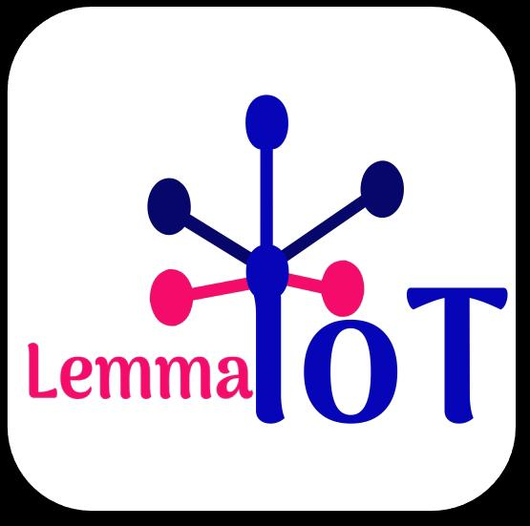

[**LemmaIoT Cloud Solution**](https://lemmaiotpg.carrd.co/)**​**:. | ​**234 706 873 0484 | info.lemmaiot@gmail.com**